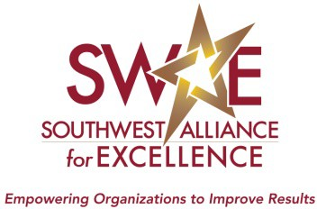

Southwest Alliance for Excellence Leadership Award

2022 Nomination Form
A nomination submission includes a nomination form, a biography or curriculum vitae (no more than 3 pages), a headshot photo and a nomination essay.

Part I - Nomination Cover Page

Nominee

Name: Title: Organization: Street Address: City, State and Zip Code: Phone number: # of Years lived in Southwest:
Email address:

Nominator (single point of contact)

Name: Title: Organization: Street Address: City, State and Zip Code: Phone number:
Email address:

If more than one nominator, include each of the nominator’s name, title and current organization

Additional Nominator (if applicable)

Name: Title: Organization:

Part II – Nomination Instructions

- Attach the nominee’s biography or curriculum vitae as a separate document (No more than 3 pages).

- Attach a headshot photo of the nominee.

- Attach a nomination essay that uses up to 1,000 words to answer the two questions below:

  - HOW does the nominee address SWAE Core Values and other award criteria? Please provide examples.

  - WHAT specific outcomes have been achieved?

The essay should be typed, single-sided, double-spaced, and in a 12-point font.

Please note that letters of support or links to websites will not be considered in the selection process and should not be submitted with the nomination.

Part III – Submittal Information

Mail or e-mail the submission to Info@SWAE.org

Part IV – Nomination Deadline

Nominations must be received by Friday, December 3, 2021 to be eligible for 2022 Leadership Award.

