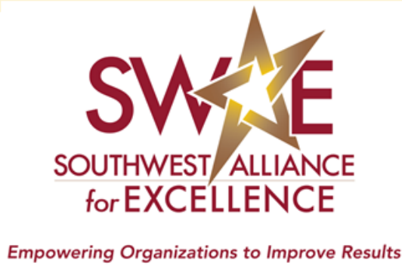

2022 Level 2 - 4 Application Packet

Southwest Alliance for Excellence
www.SWAE.org
480-874-5815
Info@SWAE.org

Letter from the Board of Directors

What does the Southwest Alliance for Excellence do?

As the Southwest Alliance for Excellence (SWAE) embarks on its 31st year serving organizations we will continue to help organizations become more efficient and improve their results!

SWAE helps organizations of all sizes, sectors, and industries improve their results using the Baldrige Excellence Framework – a systems approach to improving your organization’s performance. The Criteria for Performance Excellence helps to simplify an organization’s efforts. It is designed to help identify what really matters to your organization, and focus efforts where they will count. Using the Criteria gives you a holistic assessment of where your organization is and where it needs to be. Use it to empower your organization to reach your goals, improve results, and become more competitive by aligning your strategy, processes, decisions, people, actions and results.

At first glance, the Criteria may seem a bit dense and daunting, but SWAE offers many resources to help you learn: The SWAE Performance Excellence Program, our workshops, examiner training, and our Annual Sharing of Best Practices & Awards Luncheon are all first-rate avenues toward excellence.

I also would like to talk about why we do it: SWAE’s mission is to empower organizations in Arizona, Nevada and Utah to pursue performance excellence, improve outcomes and contribute to the economic strength of their community and state. We are dedicated to making our states better places to live and work.

Our ultimate stakeholders are the citizens of Arizona, Nevada and Utah – you and me. When our businesses, schools, hospitals, factories and government bodies focus on results, when they function at high performing levels, we all benefit.

SWAE believes, by integrating the principles of the Criteria for Performance Excellence, our organizations, communities and citizens will thrive. I am delighted that you are here to take advantage of this opportunity.

Sincerely,
Tyson Heath
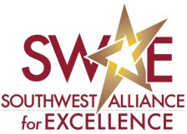
Chairman, SWAE Board of Directors

Performance Excellence Program Overview
Modeled after the Baldrige Performance Excellence Program, SWAE fulfills its mission by providing in-depth, low-cost assessments of organizations in the Southwest region using the Criteria for Performance Excellence. This process is the basis of the Southwest Alliance for Excellence Performance Excellence Program. Organizations that go through an assessment receive detailed feedback that may be used to improve processes and results. It’s an effective way to energize employees, sharpen focus, look at your organization from a systems perspective and earn recognition for your business or organization.

The SWAE Performance Excellence Program is multi-tiered, offering five levels of review.

- An organization that is new to the Criteria can get its feet wet by starting with a Level 1 (Interest) application or a Process Level (Showcase in Excellence) application.

- As the organization grows and develops, it may apply for a Level 2 (Commitment), Level 3 (Achievement) and Level 4 (Excellence) Assessment and Award. Among other eligibility requirements, organizations that apply for a Baldrige National Quality Award must first receive SWAE’s top recognition: The Pinnacle Award for Excellence.

To participate in the SWAE Performance Excellence Program, organizations submit a self-assessment based on questions posed in the Criteria for Performance Excellence. The length and breadth of this self-assessment depends on the award level sought. Please refer to the tables at the start of this packet for more details on requirements for each level.

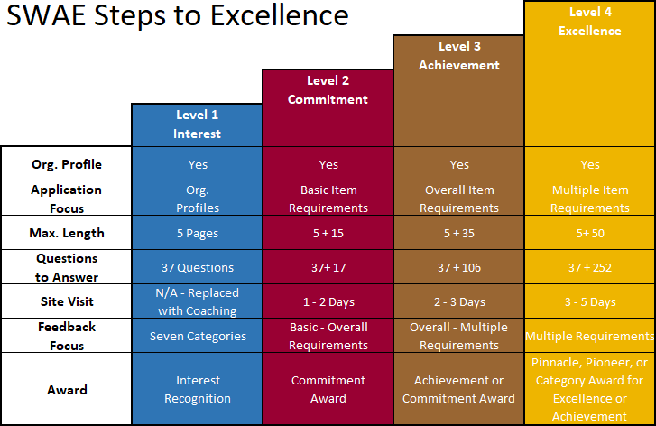

 | Org. Level 1  Interest |  | Org. Level 2  Commitment | Org. Level 3  Achievement |  | Org. Level 4  Excellence
Intent to Apply/ Eligibility Form  with 50% Application fee & 100% admin fee | Not required |  | Required  Deadline to Submit: June 29, 2022 | Required  Deadline to Submit: June 29, 2022 |  | Required  Deadline to Submit: June 29, 2022
Application Form and Fee | Level 1: Applicants must use the Application Form in the Level 1 application packet and answer all the Organizational Profile questions. 100% of the application fee is due with the application. There is no administrative fee, and application can be submitted at any time during the year.  Levels 2, 3 and 4: Applicants must answer all the Organizational Profile questions and must accompany the Responses to the Criteria. Remainder of application fee due at time of application submittal. Deadline to Submit: August 15, 2022
Response to Criteria (using the 2021-22 Criteria Booklet for Levels 1-4 for 2021 program cycle). | Not  Required | - 7 categories,  - Basic item requirements  (15 pages max.)  - Org Profile + 17 Criteria Questions |  | - 7 categories,  - Overall item requirements.  (35 pages max.)  - Org Profile + 106 Criteria Questions | - 7 categories,  - Multiple item requirements. (50 pages max.)  - Org Profile + 252 Criteria Questions
Site Visit | N/A –  Replaced with  coaching | 1 - 1.5 Days |  | 2 - 2.5 Days | 3 - 5 Days (depending on size of organization)
Recognition Eligibility | Interest Recognition | Commitment Award |  | Achievement or Commitment  Award | Pinnacle, Pioneer or Category Award for Excellence or Achievement Award
Applicant Responsibilities | N/A | Provide at least one SWAE examiner |  | Provide at least one SWAE examiner  Assistance to other organizations | *Provide at least one SWAE examiner  *Assistance to other organizations  *Participation in annual Sharing of Best Practices & Award Luncheon  *Benchmarking Tour/ Best Practices Workshop

Application Fees
- At least 50% of the application fee AND the entire administration fee (see below) is due with the submission of this Intent to Apply and Eligibility Form. The remainder is due when the application is submitted.

- Workforce size is based on the number of full-time equivalent (FTE) employees working for the applicant. FTEs are defined as those who regularly work 40 or more hours a week and are entitled to benefits such as paid vacation, sick leave and insurance coverage. Part-time workers are counted as total part-time hours per week divided by 40. For example: 10 people at 20 hours is equal to 5 full time equivalent employees (10*20 / 40 = 5). Each instance of job sharing, where multiple individuals fulfill the responsibilities of a single position that requires 40 or more hours per week, is counted as a full-time equivalent employee.

- Site visit fees are a reimbursement of actual costs, are in addition to the application fees listed below, and are invoiced separately to the applicant at actual expense amount. The applicant will reimburse the examiner team’s expenses for transportation, lodging and food, etc. associated with the site visit. The applicant may estimate and pre-pay a portion of these costs prior to scheduling the visit. The remainder will be paid after the site visit. Site visit length for a Level 2-4 application is up to 5 days. Please refer to the Application Guidance Manual for more information on the site visit process and fees.

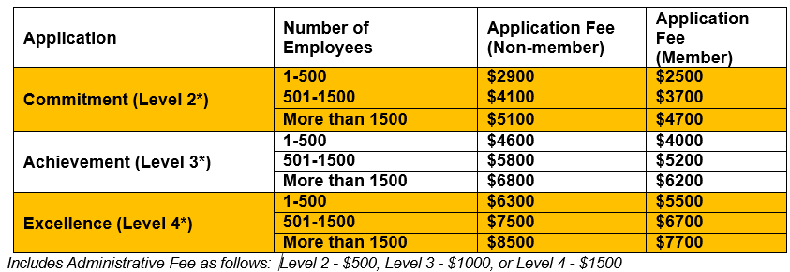

Assessment, Feedback and Recognition Process

- File the Intent to Apply and Eligibility Agreement form (by stated deadline) with applicable fees. (Level 1 Applications do not require an Intent to Apply Form and can be submitted at any time of the year) All fees are non- refundable but can be used in the following year. Fees may be submitted via check, ACH, or credit card (5% fee applies). Contact SWAE for further information.

- Submit an electronic application that meets the formatting requirements outlined in this packet (no paper copies of applications will be accepted). The applicant will provide an electronic copy in a Portable Document Format (PDF). Remit remaining fees via check, ACH, or credit card (5% fee applies).

- Host the examiner site visit (if applicable) and reimburse SWAE for the team’s expenses . During the site visit, a team of SWAE examiners evaluates the application and conducts a site visit to gain a thorough understanding of the organization. Note: An organization that submits a feedback-only application may choose not to receive a site visit. There is no reduction in the Application Fees, but no site visit or site visit expenses will be included in the assessment. The feedback report will then be based on the consensus score of the examiner team. The Site Visit is a vital part of the assessment process. Although an organization may choose not to host the Site Visit, the value of the feedback report will be reduced by this choice. If an organization declares that its application is for Feedback only, this declaration cannot be changed after the application is submitted to the Southwest Alliance for Excellence.

- Receive a detailed Feedback Report that identifies the applicant’s strengths and opportunities for improvement. The Panel of Judges reviews the examiner team’s work for integrity and completeness and determines the applicant’s award level (if any).

- Attend the SWAE Performance Excellence Program Awards Banquet. The SWAE Performance Excellence Program Sharing of Best Practices & Awards Luncheon is the platform SWAE uses to recognize organizations that complete the evaluation and feedback process. During the luncheon, each SWAE applicant that has fulfilled the criteria requirements receives an award based on its level of achievement. For employees of organizations that participate in the application process, the luncheon is a great celebration, confirming the organization’s commitment to improving performance results.

Application Content and Formatting Requirements
- The application submittal consists of:
- Title Page
- Table of Contents (page #’s of each Category Item)
- Organization Chart
- Glossary of Terms and Abbreviations
- Organization Profile (not to exceed 5 pages)
- (Level 2-4) The Responses to the Criteria Items (not to exceed specified # pages per Level).
  - Organizations must submit an electronic application that meets the formatting requirements. (No paper copies of applications will be accepted)
  - Electronic applications must be provided in PDF format.

Formatting the Application
  - Consider each of the questions listed in the criteria in the level you are applying.
  - Use the same category and item numerical designations as in the criteria.
  - The application should be formatted:
- Page size: 8 ½ by 11 inch size
- Page orientation: Portrait / Pages with graphs; figures & tables: portrait or landscape
- Lines per page: 60 (includes headings and blank lines separating paragraphs; does not include headers/footers with recurring info, i.e. org. name, page #, etc.)
- Leading: 2 points between lines (1 point of leading equals 1/72 or 0.0138 inch)
- Margins: Left = ¾ inch minimum; Right = ½ inch minimum
- Text Columns: 2 preferred with ¼ inch between columns
- Numbering: pages that respond to all criteria items should be numbered as such, i.e. Org. Level 4 (1 - 50), Org. Level 3 (1 – 35) or Org. Level 2 (1 – 15); don’t number blank pages, or use small Roman numerals, i.e. iii, iv, etc..
- Figure Numbers: Figures within Organizational Profile and Item sections should be in sequence; use numbers corresponding to the section (e.g., Figure P.1-1, Figure 2.1-2)
- Font and type size:
  - Running text: 10 points minimum; Times New Roman or Arial
  - Do not use narrow, compressed, or condensed fonts
  - The font and type size need not be uniform as long as they meet the requirements
  - If you shrink graphics to fit the space available, ensure that text in the reduced figure meets the requirements
  - Tables filled mainly with text: 8 points minimum; Times New Roman or Arial
  - Other graphics (charts, graphs, data tables, and other figures), including titles and captions: 8 points minimum; any font
  - Clearly label each figure using descriptive text. For example, the title of the third figure for results Item
2.1 might read “Figure 2.1-3 Reliability of Service: Carrier-Dropped Calls.”
  - Clearly label all axis and units of measure
  - All components of the application must be in ONE document; i.e. the title page, table of contents, organization chart, glossary, organization or profile, and the responses to the criteria items.

Page Limits and Exclusions
- Criteria response page limits must include all pictures, graphs, figures, tables, and appendices. These pages must be consecutively numbered. Page limits do NOT include Organizational Profile or Process Profile or Context, glossary, title pages, organization chart, or table of contents.

Application Content and Formatting Requirements (cont.)
- Examiners must base their evaluations solely on information contained within the application report. Do not add links to information on internet or websites. Examiners are instructed to rely solely on the content in the application and are not allowed to follow any such links.
- Do not submit copies of video, audiotape or other information aids.

An application that does not comply with all of the requirements, including the permitted page limit, font size, and margins will not be accepted by SWAE. Keep in mind that font size and formatting is to match criteria stipulated in the application, even after figures and graphs have been inserted and saved as a PDF file. The final copy will be tested for format requirements.

It is suggested that you submit your final application before the due date to avoid potential issues. You may set up an appointment with SWAE to review and ensure your application meets formatting requirements.

Code of Ethical Standards
Code of Ethical Standards Integrity is one of SWAE’s core values. A strict Code of Ethical Conduct and Conflict of Interest Statement binds each examiner and judge. Neither examiners nor judges may participate in any evaluation; scoring or recognition decisions where there may be, or could appear to be, any personal, potential or perceived conflict of interest.

Applicant Eligibility
Any public or private organization located in the states of AZ, NV or UT may participate in the SWAE Performance Excellence Program. Organizational Units Business/organizational units or subsidiaries are eligible to submit an application. For purposes of the evaluation process, a subsidiary means an actual subsidiary, business unit, division, or district office. Eligible organizations must be recognizable as discrete entities and must be easily distinguishable from parent and other sub-units. They must function as business or operational entities, not as activities assembled to write an application. Organizations must be self-sufficient enough to be examined in all seven Criteria categories. For example, an organizational unit with its own administrative, human resources and other support functions is eligible; but a unit that is entirely dependent upon the parent organization for the majority of these functions is ineligible. The following organizational units are expressly allowed:

• Business units or larger • Whole manufacturing plant
• Hospitals within systems; whole health care systems • Stand-alone sub-units of larger orgs
• State government office/division/department • School districts
• Colleges within Universities; whole universities • Individual schools

Note: Meeting eligibility requirements for SWAE Level 4 awards does not necessarily convey
eligibility as a national Baldrige Applicant.

If an organization receives the Pinnacle Award for Excellence (Level 4), the organization is ineligible to apply for another SWAE organization level Award for a period of three years. For example, a 2014 Pinnacle Award recipient would be eligible to reapply in 2018. Recipients of the Pioneer Award may re-apply in any given year but may not receive the Pioneer Award more than once every three years. There is no such restriction for Interest Recognition (Level 1), Commitment Awards (Level 2) or Achievement Awards (Level 3).

Eligibility Determination
In order to ensure fairness and consistency to all award applicants, an Intent to Apply/Eligibility Form is required for Organization Levels 2, 3 and 4 applicants and Process Level applicants. This form takes into account an organizational unit’s structure, functions and performance. Potential applicants are encouraged to submit the Intent to Apply/Eligibility Form as early as possible.

Awards
A final review of all applications is conducted by the Panel of Judges. The Panel of Judges review the examiner team’s work for integrity and completeness then develops a recommendation for each applicant. This recommendation is forwarded to SWAE and includes the determination of the level of award for each recipient. Due diligence is performed for all recommended recipients to determine if there are any other outstanding issues that may affect their selection as a Performance Excellence Program Recipient. The purpose of this final review is to ensure that the integrity of the Program and Awards is maintained.

Awards are granted on the basis of fulfilling the Criteria requirements described for each level. There is no limit to the number of awards presented annually. However, if no candidate demonstrates the levels of performance excellence outlined in this section and established by the Criteria, no award will be conveyed. In other words, there may be years when no recipients are named, particularly at the higher award levels.

Level 2 – Commitment Award
Level 2 is the intermediate level of the SWAE Program. It recognizes organizations that are beginning to demonstrate serious commitment to, and implementation of, performance improvement principles. To apply at this level, organizations must submit the Organizational Profile answering all questions described in the Criteria booklet (pages 4-6). Applications also include the signature of the highest ranking official, indicating his or her commitment. In addition, the organizations complete a self-assessment (up to 15 pages long), detailing how they apply the Basic Item Requirements of the seven categories outlined in the Criteria booklet. It is important that applicants at this level clearly note processes that have been systematically improved based on data and assessment. Level 2 applicants host a 1 - 1.5 day site visit conducted by a team of SWAE examiners. Recipients of Commitment Awards have demonstrated progress by identifying and putting in place some key process improvements, which are directly attributable to a fact-based improvement process. The organization has addressed the Basic Item Requirements within each category of the Criteria. At this level, results may or may not be evident; however, a measurement system should be in place to capture data and analyze results.

Level 3 – Achievement Award
Level 3 is an advanced level of participation. It recognizes organizations that have demonstrated, through their commitment to and practice of performance improvement principles, significant progress and results in building sound processes. Level 3 applicants must submit the Organizational Profile answering all questions described in the Criteria booklet (pages 4-6) and the signature of the highest ranking official, indicating his or her commitment. The application also includes a self-assessment (up to 35 pages long), detailing how the organization applies the Overall Item Requirements of the seven categories outlined in the Criteria booklet. Level 3 applicants host a comprehensive 2 – 2.5 day site visit conducted by a team of SWAE examiners. The year after receiving the Achievement Award, organizations are expected to provide voluntary assistance to organizations that are new to the SWAE performance excellence process. Recipients of Achievement Awards have demonstrated significant

Awards (cont.)

Level 3 – Achievement Award (continued)

progress in building systematic processes that effectively address the overall requirements of each item. These processes are deployed and aligned throughout the organization appropriately to meet the key needs of the organization. Results for some key processes show improvement (at least a year in most cases) that is directly attributable to a systematic improvement approach. These organizations have many practices from which other organizations can learn and grow.

Level 4 – Excellence Award
The highest level of recognition is presented to organizations that have demonstrated, through their practices and achievements, the highest level of performance excellence. Only 6 organizations have attained the Pinnacle Award for Excellence (formerly called the Governor’s Award for Quality). Their success is typically the result of applying feedback from previous SWAE applications. There have been 35 recipients of the Pioneer Award for Excellence and 1 recipient of the Category Award for Excellence. The Pinnacle Award for Excellence recognizes organizations that have mature and fully-deployed quality systems within their operations that demonstrate a commitment to continuous improvement and have a sustained significant record of performance. Organizational learning, including innovation and sharing of best practices, is a key management tool. Current performance results have been evaluated against relevant comparisons or benchmarks and show areas of favorable performance for most key customer, process and market requirements. The Pioneer Award for Excellence recognizes organizations that demonstrate effective, systematic approaches that are aligned with the organizational needs. Deployment may vary in some areas. Results show good performance and comparative and trend data are available for some important results areas. Some beneficial trends are evident but sustained excellence has not been achieved. The Category Award for Excellence recognizes organizations in one or more of the six categories: Leadership; Strategy, Customers; Measurement, Analysis, and Knowledge Management; Workforce; and Operations. In each case, the organization will achieve recognition based on its performance in that category and the results related to that performance. An application at this level requires submission of the Organizational Profile answering all questions described in the Criteria booklet (pages 4-6) and the signature of the highest ranking official, indicating his or her commitment. The application also includes a self-assessment (up to 50 pages long) detailing how the organization applies the Multiple Item Requirements of the seven categories outlined in the Criteria booklet. Level 4 applicants host a comprehensive 3 - 5 day site visit conducted by a team of SWAE examiners. The year after receiving the Excellence Award, organizations are expected to provide voluntary assistance to organizations that are new to the SWAE performance excellence process. Additionally, Excellence Award recipients are asked to participate in the annual Awards Banquet, and host a Benchmarking Tour/Workshop the year following their achievement

Site Visit Expenses and Protocol
Site Visit costs may be estimated and partially paid by the applicant prior to the scheduling of the Site Visit. After the Site Visit is completed and expenses have been tabulated, applicants will be invoiced by SWAE for the actual amount of the examiner team expense. This may include lodging, food, meeting room costs for the examiner team at their place of lodging, and travel and/or roundtrip mileage to the applicant’s location. Examiner teams endeavor to keep the costs of the Site Visits as low as possible. Expenses of the Site Visit mentor, if any, will be included with the costs of the other team members.

The examiner team will request that the applicant provide a common meeting area on site for the team for the duration of the Site Visit. This area should be secure during the periods of the team’s on-site activities and should be kept secured when the team is not on-site. All documentation requested by the team for examination will be reviewed in the team’s meeting area – these materials will not be taken off-site by the examiners. If the applicant has restrictions or requirements on the possession or use of personal computer devices, citizenship, security clearances, etc., they should notify SWAE of these constraints prior to submittal of their application.

To avoid any appearances of impropriety or perceptions of undue influence on the examiners by the applicant, examiners are not permitted to accept gifts, tokens of appreciation, or other items as part of the Site Visit. The team will arrange for their accommodations and travel, and may not accept lodging or other services from the applicant. Even if it is available as part of the applicant’s normal business or provided at market rates, the team will not accept accommodations from the applicant. SWAE may ask the applicant for contact information on convenient accommodations as they prepare for the Site Visit.

Feedback Report
The feedback report, a tool for continuous improvement, is a written evaluation by an evaluation team from the Board of Examiners. Each applicant organization will receive a full feedback report at the conclusion of the review process. The feedback report contains an applicant-specific listing of strengths and opportunities for improvement based on the Criteria. When used by organizations as part of their strategic planning processes, the feedback report can help them focus on their customers and improve productivity. The feedback system is one of the most important components of the Performance Excellence Program process; it provides a pathway for continuous improvement. Strict confidentiality is observed at all times and in every aspect of application review and feedback.

As a value-add to all applicants, whether or not an award is received, SWAE offers each applicant the opportunity to meet with the Lead Examiner and Lead Judge on their application in addition to the SWAE Executive Director to review their final feedback report. These have been very positive and helpful to each applicant.

Baldrige Criteria
There are three versions of the Baldrige Criteria for Performance Excellence: Business/Nonprofit, Health Care, and Education. More information on the criteria is available online, and booklets can be purchased at: Baldrige Excellence Framework | NIST. Volume discounts are available for both electronic and printed formats.

The Southwest Alliance for Excellences offers tailored workshop and webinar opportunities to help organizations better understand the criteria. Visit the SWAE website ‘Event” tab, or email Info@SWAE.org for more information. Annual SWAE examiner training also provides a valuable opportunity to learn about the criteria.

